NAME: VENKATRAMAMOORTHY.G
- Use map to double all numbers in an array.
CODE:
let a=[];
for(let i=1;i<=5;i++){
a.push(i);
}
console.log(a);
let b=a.map(b=>b*2);
console.log(b);
OUTPUT:
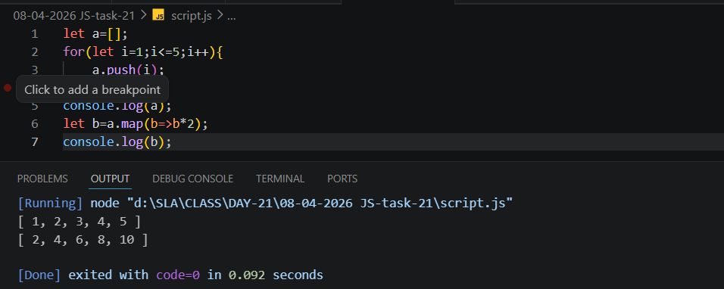
- Use filter to get even numbers from an array.
CODE:
let a=[];
for(let i=1;i<=5;i++){
a.push(i);
}
let c=a.filter(b=>b%2==0);
console.log(c);
OUTPUT:
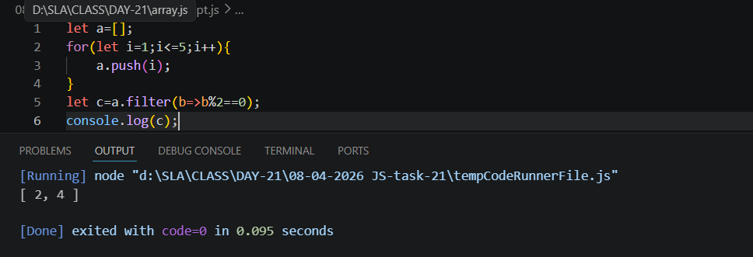
- Use reduce to find the sum of an array.
CODE:
let a=[];
for(let i=1;i<=5;i++){
a.push(i);
}
let d=a.reduce((a,c)=>a+c,0);
console.log(d);
OUTPUT:
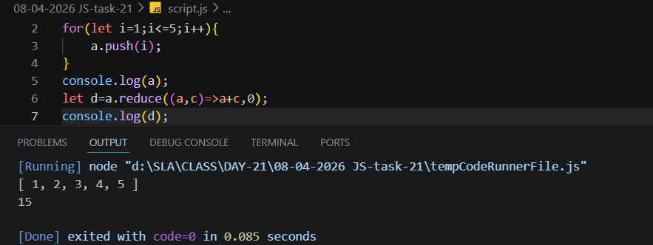
- Find the first number greater than 10.
CODE:
let a=[];
for(let i=1;i<=5;i++){
a.push(i);
}
console.log(a);
let b=a.map(b=>b*2);
console.log(b);
let e=b.map(b=>b*2);
console.log(e);
let f=e.find(a=>a>10);
console.log(f);
OUTPUT:
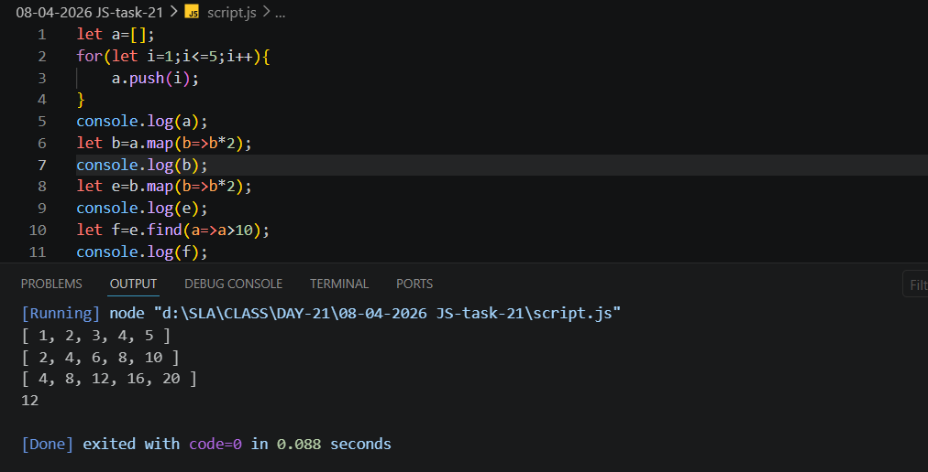
- Check if array includes a specific value.
CODE:
let a=[];
for(let i=1;i<=5;i++){
a.push(i);
}
console.log(a);
let g=a.includes(3);
console.log(g);
OUTPUT:
